Market Data Dashboard Assignment



Thank you for your interest in joining the Releaf engineering team!

We appreciate your interest in working with us as a full-stack developer! Given that we have an existing development stack already, there is a learning curve and as such we have outlined a test task to ensure you are capable of working with us effectively.

We've outlined a short project below which will help us assess your skills and working style as a developer. While part of our goal is to see the choices you make in completing this task, please contact us if you feel there is any ambiguity. We estimate the project should take between 6 and 10 hours depending on your prior experience. If you finish early, please devote more time to design and aesthetic - as we’ll be putting a high emphasis there.

We currently have an open source implementation of market data trends and we’d like to evaluate your ability to implement the same.

**Assignment**

Using data exclusively sourced from the Nigerian Bureau of Statistics, we’d like for you to synthesize and present Nigerian agricultural market trends over time on a dashboard.

Ideally, we want you to demonstrate how prices will grow or diminish over time. Your finished implementation should allow users to select a state in Nigeria and a specific crop from a drop-down list and dynamically see an updated graph presenting the price trend from 2016-2019. *Price information will be provided in the form of an Excel spreadsheet obtained from the Nigerian Bureau of Statistics (please use the spreadsheet’s **Urban** prices).*

This tool’s intended user will be Nigerian agribusiness owners, who are looking for an edge against their competition. They would use the dashboard to see the price/demand trends of the various crops that they deal with. That way, they could understand which crops they should be prioritizing or pivoting away from.

See a rudimentary sketch on the next page:

* Step 1 and Step 2 (map and graph) should be side-by-side on the same page; that way, the user can dynamically switch between crops and states without needing to go to a previous page
* User should be able to interactively click the state(s) shown on the map as an alternative to choosing from the drop-down list
* Bar graph should instead be a line graph, to better demonstrate change over time
* Ability to select the year that is displayed on the Nigeria map; that way, businesses can see how prices shift across the country over time
* Ability to compare multiple crops’ price trends at the same time; i.e. multiple lines on the line graph
* Instead of checkboxes, price and demand options can be tabs over the graph.
* The state drop-down list should precede the crop drop-down list.

**Platform Dashboard**

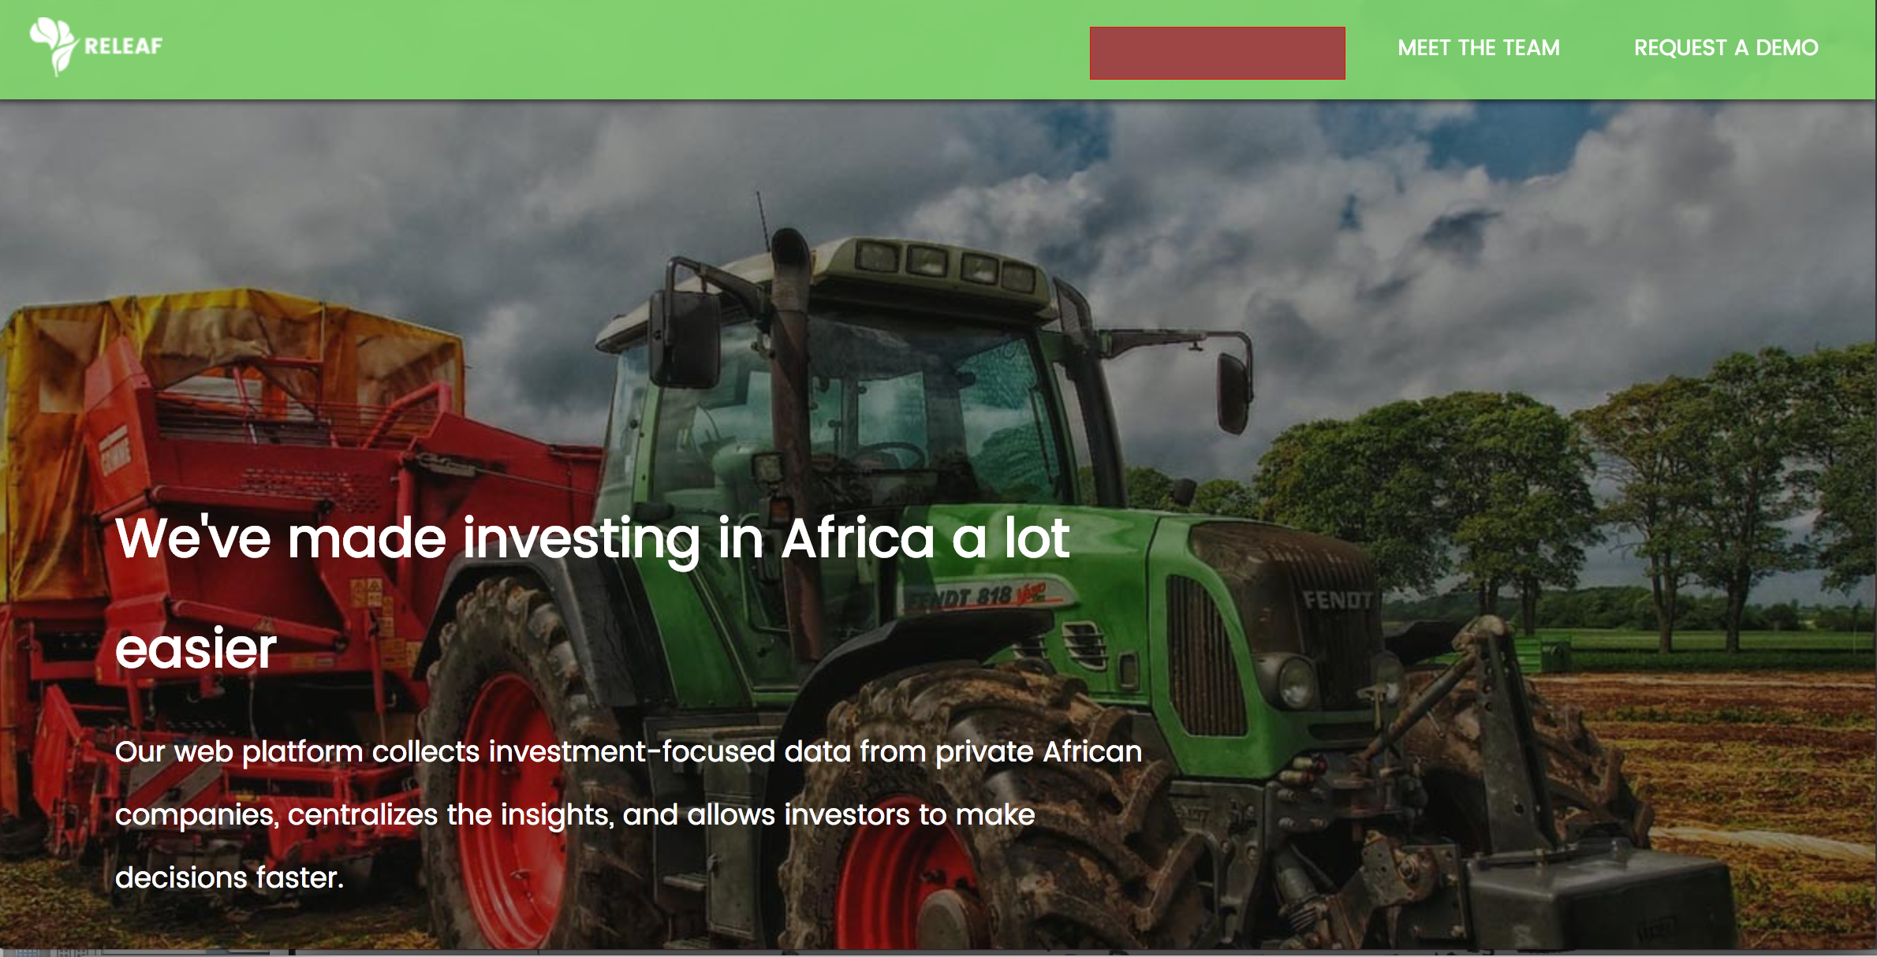

**Logistical Details:**

Please provide your email for Github as you will be invited on the Github repo for your assignment. You will be creating your own branch on the [**releaf-front-end**](https://github.com/releafgroup/releaf-front-end)directory on the Github.

Create the header **Market Dashboard** where the **red box** is in the picture above. Link the routing to the project to this header.

**We strongly encourage paying close attention to detail and aesthetic, writing clean code, and documenting your process thoroughly. As long as the base specification is done, we will only look favourably on extra initiatives.**

**Please show a gif demo of this on the Github repo demonstrating the functionality.**

Be sure to reach out if any part of the assignment is giving too much difficulty. Should you have any questions regarding this specification or the project as a whole, please contact emmanuel@releaf.ng.

Good luck, and have fun!